EUROPEAN DAY OF LANGUAGES QUIZ – KS2

COUNTRY | LANGUAGE SPOKEN | ARTEFACT
Malta | Maltese, English | P Maltese cross
Germany | German | D piece of Berlin wall
France | French | C Eiffel Tower
Spain | Spanish | I Flamenco dress
Belgium | French, Flemish | M chocolate
Italy | Italian | J Roman soldier
Greece | Greek | B Aladdin book
Denmark | Danish | G Andersen book
Sweden | Swedish | K Volvo car
Finland | Finnish | N Nokia phone
Poland | Polish | H authentic postcard
Portugal | Portuguese | L Fado music CD
Austria | German | Q Mozart CD
Croatia | Croatian | F tie pin
Estonia | Estonian | T swallows (top)
Hungary | Hungarian | R Rubik’s Cube
Ireland | English, Irish | E shamrock
Lithuania | Lithuanian | O amber

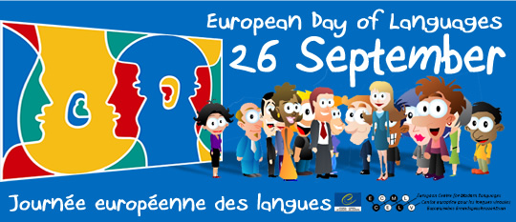
Funded by Europe Direct North East

