EUROPEAN DAY OF LANGUAGES QUIZ – KS1

A Germany English
B France Greek
C Spain French
D Poland Italian
E Denmark Polish
F Greece German
G Italy Irish, English
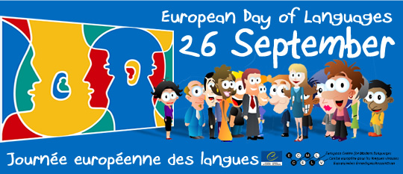
H Ireland Croatian
I Great Britain Spanish
J Croatia Danish

Funded by Europe Direct North East

