EUROPEAN DAY OF LANGUAGES QUIZ – KS2

COUNTRY | LANGUAGE SPOKEN | ARTIFACT
Malta
Germany
France
Spain
Belgium
Italy
Greece
Denmark
Sweden
Finland
Poland
Portugal
Austria
Croatia
Estonia
Hungary
Ireland
Lithuania

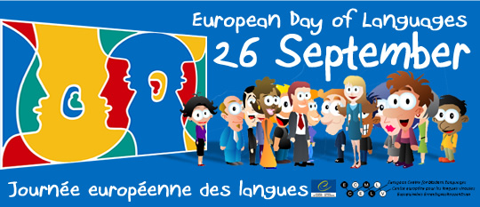
Funded by Europe Direct North East

