Pomme de reinette et pomme d'api,
Tapis, tapis rouge.
Pomme de reinette et pomme d'api,
Tapis, tapis gris.

English
Pippin apple and lady apple,
Carpet, red carpet,
Pippin apple and lady apple,
Carpet, grey carpet.

When I was little, we used to sing this whilst swapping over our fists, on top of each other, to fit in with the rhythm of the rhyme, as I demonstrate in the video; however, feel free to come up with your own gestures.
The only extra line I knew as a child was: “Cache ton poing derrière ton dos sinon t’auras un coup de marteau” (hide your fist behind your back, otherwise you will get hit by a hammer)! It got me thinking about the noun “poing” in French (fist) and the adjective “poignant” in English. Are they related? Click here to find out!

I had to get help from the fantastic Mama Lisa website to find out more about the whole rhyme! Click here to check it out!

This can be used as a simple rhyme/song when you want to practise the words for apple in French, but also to introduce or revisit the fact that adjectives in French come after the noun that they describe.

It also shows or reminds you that the letters “t” and “s” are normally silent at the end of French words – as in “et”, “tapis” and “gris” here.

This rhyme therefore looks like there is not much to it… but you can exploit it in so many ways!

Click here to go back to the article and the video about those 2 apples!
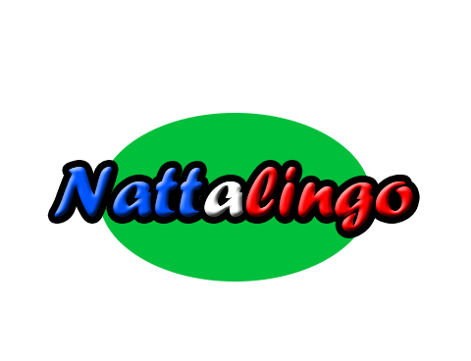
www.nattalingo.co.uk

